AGRI SHOP ONLINE APPLICATION
LOW LEVEL DESIGN

Overview of Agri Shop Online:
The main objective of this project is to design an Agri shop Online application that will allow the customer to purchase a product, farmers are used to add products and quantity and prices of the products.
Procedure Flow:
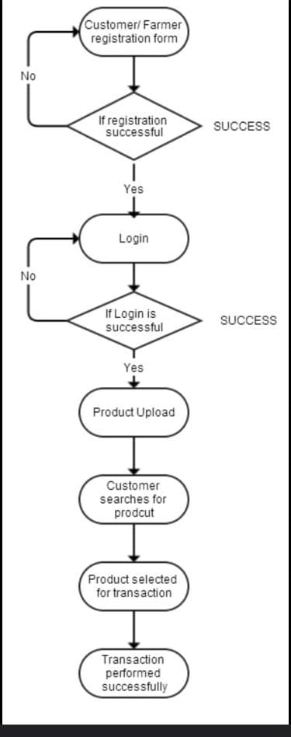

User Registration:
If a customer and farmer want to create a new account first, they must register with 12 digits Aadhar number and personal details with a like name and phone number.
Password Validation:
The password should be a combination of Upper-Case Letters, Lower Case Letters, Numbers and Special character.
Create Account for Customer & Farmer:
On successful registration the farmer can upload his product and prices and quantity regarding it. Customer can purchase any product from the online shop.
Procedure Flow:

Customer/ Farmer Login:
Customer has to login with name and password, if the password is correct, he/she can process further.
Admin:
Admin can add, edit, view and delete records/products of farmers and customers. Payment details will be sent by the admin.

